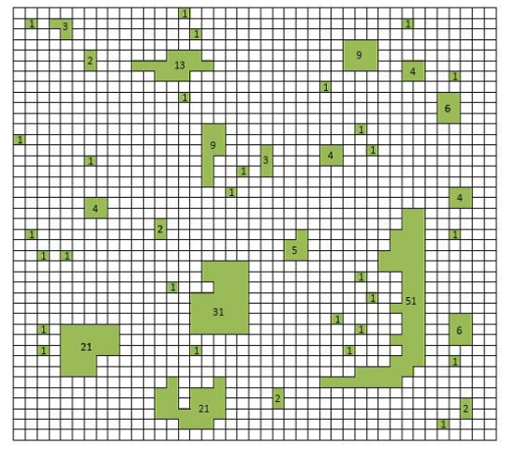
 | Minimum  habitat  requirement (cells) | Maximum  dispersal  distance (cells) | Largest  component  index (H_{lc}/H_{total}) | Link  Density  L/[n(n-1)/2]
Small  mammal | 1 | 2
Large  mammal | 16 | 32

